Guidelines for Abstract Preparation for TOCAT10

First author's first name and family name1, Second author's first name and family name2*, ...

1First author's affiliation, City, Country

2Second author's affiliation, City, Country...

*E-mail: Corresponding author's e-mail

**Abstract:** Abstract is limited to 100 words.11-points.

This is a template of abstract for TOCAT10, Tokyo, Japan, 2026. You can directly use this template without changing the format. Please fit the abstract to 1 page of A4-sized paper. Use of Times New Roman font (or equivalent) is strongly recommended.

**Keywords:** Keyword 1, Keyword 2, Keyword 3.

The title of the abstract is centered with Times New Roman font in 14-point boldface.

Authors’ names are below the title in 11-point. Mark affiliations using superscripted letters (starting from 1). Underline the presenting author’s name and asterisk (*) the corresponding author’s name. The affiliations and the contact information (E-mail address) are italicized in 11-point. The affiliations are given as department and institution names with city, zip code and country.

Texts from Abstract must be in a two-column format. Abstract is limited to 100 words, and three keywords are listed directly below the abstract. The texts of Abstract and keyword should be given in 11-points.

Main text should be given in 11-points. The font type should be “Times New Roman” for all parts including the title and references, with single spaced lines.

Tables and figures are included within 1 page. Captions of Tables and Figures are given in 10-point with one line spacing from the text body (see below). References should be indicated in the text in square brackets, such as [1-3] and listed at the end of the paper (10 points). Acknowledgement should be addressed as a last paragraph of the text body.

Convert your Word file to PDF file and submit the PDF file on the website of TOCAT10 (https://tocat.catsj.jp/10/). To avoid garbled printout, all the fonts should be embedded in the PDF file, which can be checked in the property of document. The simplest way of embedding fonts is to select "High Quality" (or "Ko-hinshitsu Insatsu" in Japanese) in property when you make a PDF file (at the same time the quality of pictures and drawings is kept).

Abstracts must be submitted by October 31, 2025. The acceptance of papers will be announced around March 30, 2026.

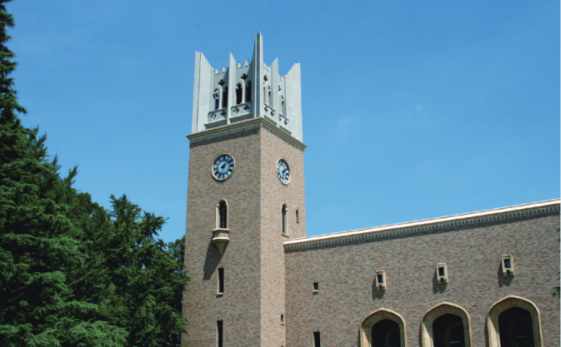

Figure.1 Ohkuma Auditorium (10-point).

Table 1. Caption of tables (10-point).

|  |  |  |  |
| --- | --- | --- | --- |
| TOCAT | Prefecture | Population | |
| Total | Rank in Japan |
| 1-5 | Tokyo | 13,960,236 | 1 |
| 6 | Hokkaido | 5,281,297 | 8 |
| 7 | Kyoto | 2,610,353 | 13 |

**Acknowledgements**

This conference is organized by the Catalysis Society of Japan and will be supported by many sponsors.

**References**

[1] M.S. Jarrell, B.C. Gates and E.D. Nicholson, J. Am. Chem. Soc., 100 (1978) 5727.

[2] L.R. Snyder, Principles of Adsorption Chromatography, Marcel Dekker, New York, 1968, p. 201.